**POWERBI PROJECT**

**PIZZA SALES ANALYTICS**

**PROBLEM STATEMENT :**

Develop a comprehensive Power BI solution for a fictional pizza restaurant chain, PizzaHub, to analyze and visualize their sales data in order to gain valuable insights into their operations and drive data-informed decisions. The goal is to provide a user-friendly and interactive dashboard that enables stores management team to track key performance indicators, identify trends, and make informed decisions to optimize their sales and improve customer satisfaction. The project will involve data extraction, transformation, and loading (ETL), data modeling, and the creation of visually appealing reports and dashboards in Power BI.

Here are the some problem statements.

* Identifying the most popular pizza toppings and sizes.
* Determining the best-selling pizzas at different times of day, days of the week, and months of the year.
* Analyzing customer demographics and purchase history to identify target markets.
* Tracking the performance of marketing campaigns and promotions.
* Measuring the efficiency of order fulfillment and delivery.
* Identifying opportunities to reduce costs and increase profits.

**Data source link :**

<https://www.mavenanalytics.io/data-playground?page=3&pageSize=5>

**EXPLORING AND IMPORTING THE DATA IN POWER BI :**

The dataset is consist of the four tables such as order details , orders , pizza types and pizzas.

Import it in the power BI query editor and explore it.

**DATA CLEANING AND TRANSFORMATION :**

Renaming the columns of the table as the required format as shown below.



Similarly the above step is repeated for all four tables.



Here we use the first row as header.



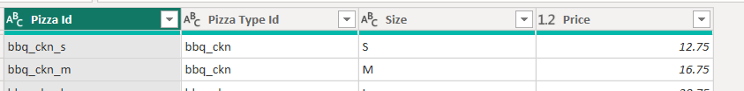

Also check the data for the replacing the null values but there is no null values in all four tables in the data.

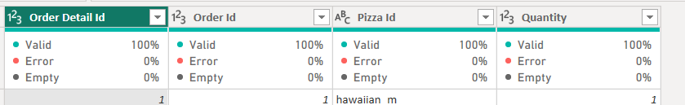

**DATA MODELLING :**

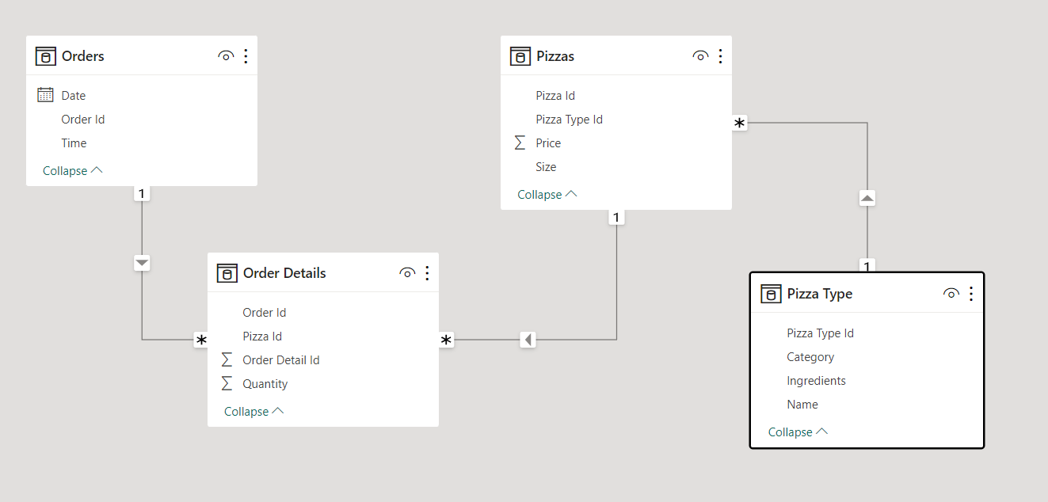

this is the relation already made between our tables.

**Creating the new table for the modelling :**

Create a new table called as the data table for the modelling. Following is the formula for the new table.

Data Table = ADDCOLUMNS(CALENDAR(MIN(Orders[Date]), MAX(Orders[Date])), "Year", YEAR([Date]), "Month", FORMAT([Date], "mmm"),"Month No", MONTH([Date]), "Quarter", FORMAT([Date], "\QQ"), "Day", FORMAT([Date], "ddd"), "Day No", WEEKDAY([Date]) )

Now creating a relationship between the new table and orders table with the date.

Just drag the date column from new table and drop it into the orders table on the data column.

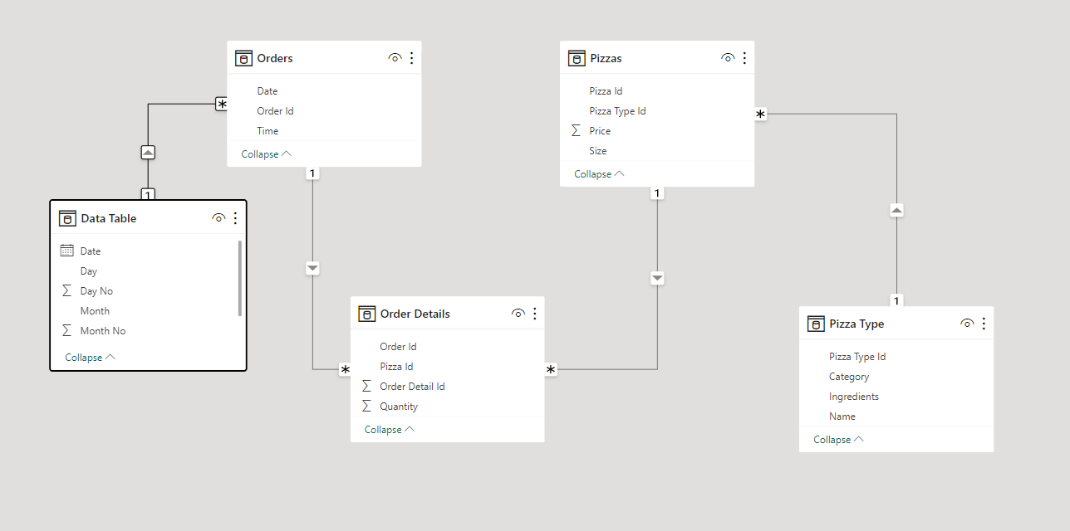

Creating a new table for all the mesures and named it as the all measures.

And create a new measure orders.

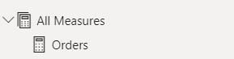

Now create a new measure named it as the total sales and formula for that measure is

Total Sales = SUMX('Order Details','Order Details'[Quantity] * RELATED(Pizzas[Price]))

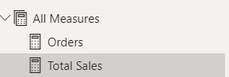

Creating a new measure named it as average orders in a day and formula for that measure is

Avg orders in a day = DIVIDE(DISTINCTCOUNT('Order Details'[Order Id]), DISTINCTCOUNT(Orders[Date]))

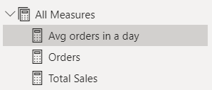

Creating a new measure named it as average pizzas in an order and formula for that measure is

Avg Pizzas in an order = DIVIDE(DISTINCTCOUNT('Order Details'[Order Detail Id]), DISTINCTCOUNT(Orders[Order Id]))

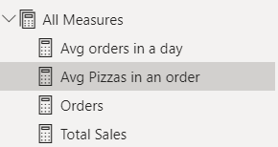

**CREATING A REPORT / VISUALIZATION :**

1. **Line chart :**

Following is the line chart which shows the sales of the per month in the year of the 2015 and from the following graph we conclude that the maximum sale is happened in the month of july and minimum sales is happened in the month of octomber.

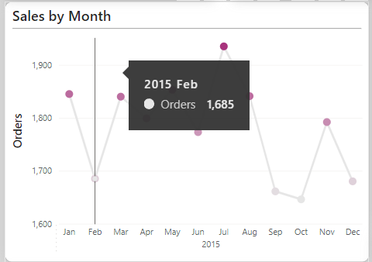

1. **Bar chart :**

the following is the bar chart which shows the peak hours of the shop sales. And from the graph we conclude that the orders are more in the afternoon 12 to 3 timings and less in the night 9 to 12.

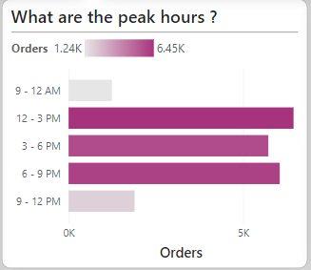

1. **Bar Chart :**

the following is also a bar chart which shows the which days are more in the week and from the graph we conclude that the Friday is a most busiest in the week and Sunday is less busiest in the week.

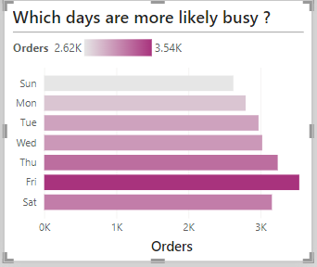

1. **Donut Chart :**

Following is the donut chart of the category which shows the percentage of the different categories of the pizza that is to be sold.

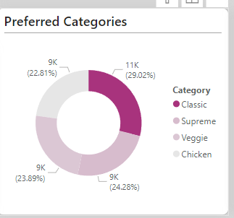

1. **Donut chart :**

The following is also the donut chart which shows the different sizes of the pizza and which size is the people orders most.

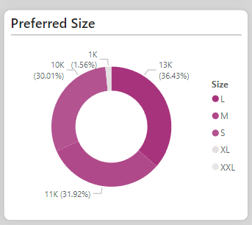

1. **Tabel view :**

The following is the table which shows the top 5 selling pizza and the bottom 5 selling pizza of the shop.

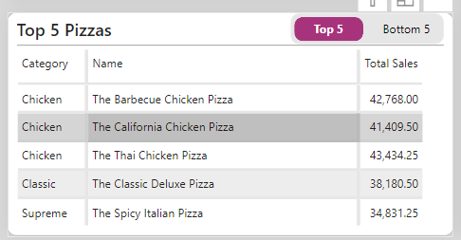

**FINAL DASHBOARD :**

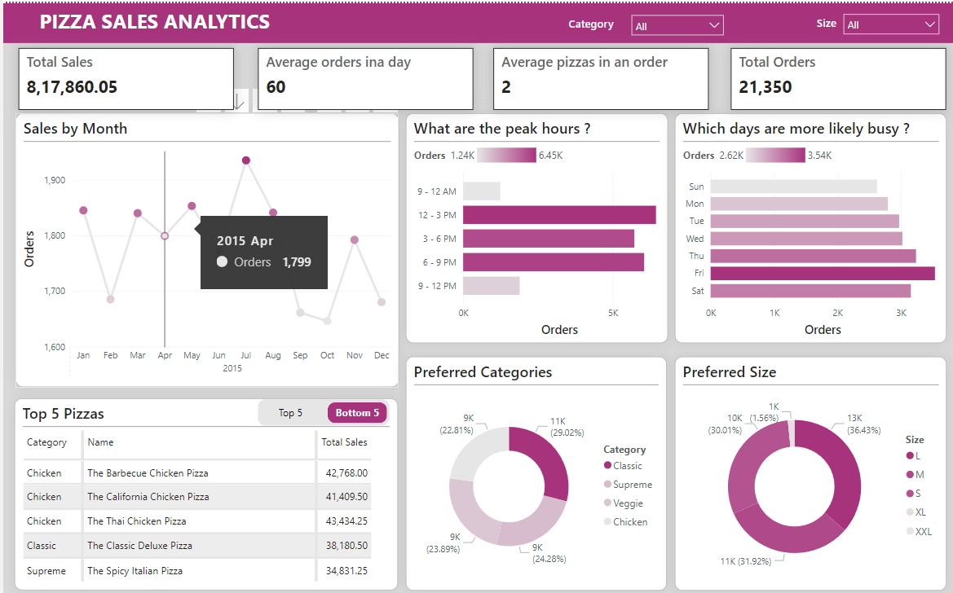

**CONCLUSION :**

1. From the dashboard we conclude that the most orders are coming in the july month and less orders are coming in the octomber month.
2. 12 to 3 is the most busiest time slot in the day and Friday is the most busiest day from the week.
3. The peak hours are 9-12 AM and 6-9 PM. These are the times when people are most likely to be hungry and looking for a quick and easy meal.
4. The most popular pizza category is Classic. This category includes pizzas like the Classic Deluxe Pizza and the Supreme Pizza.
5. The most popular size is Medium. This is the size that is most suitable for two to three people.
6. The top five pizzas are all Chicken pizzas. This suggests that Chicken is the most popular topping among customers.